# CRDR – Collaborator User Manual

### Purpose

Purpose of this manual is to detail, how a Principal Investigator can raise a request for Collaboration for an another study.

The PI who is requesting for collaborator ---Requester PI

The owner of the Study -----Study owner PI

### Login:

Login crdr.phfi.org using the “username” and “password” as a PI (Requester PI).

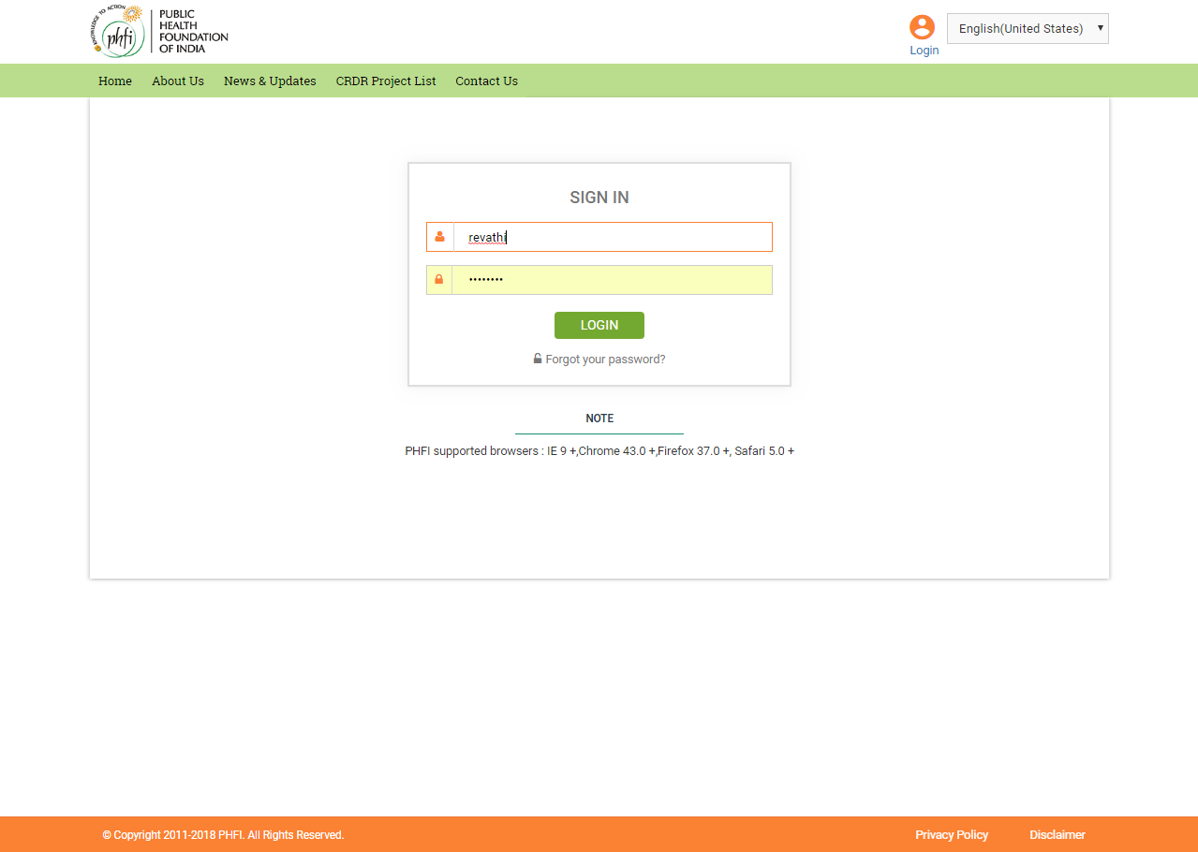

On logging in PI (Requester PI) is navigated to the Manage Studies page. All the projects assigned to the PI(Requester PI )are listed in Manage Studies page.

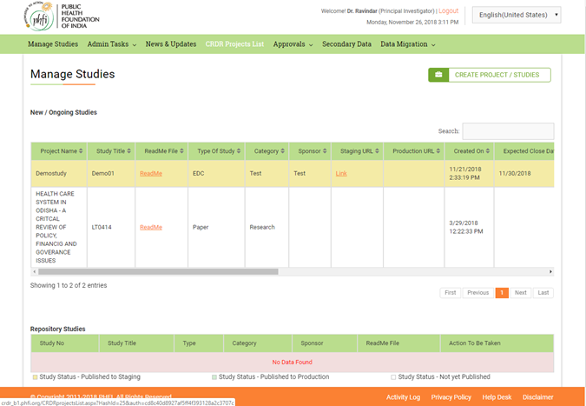

To get the list of all the projects available in CRDR system, click on the “CRDR Projects List”. On Clicking the “CRDR Project List” the below page appears. Under the “Actions” column, Request for collaboration option is available. 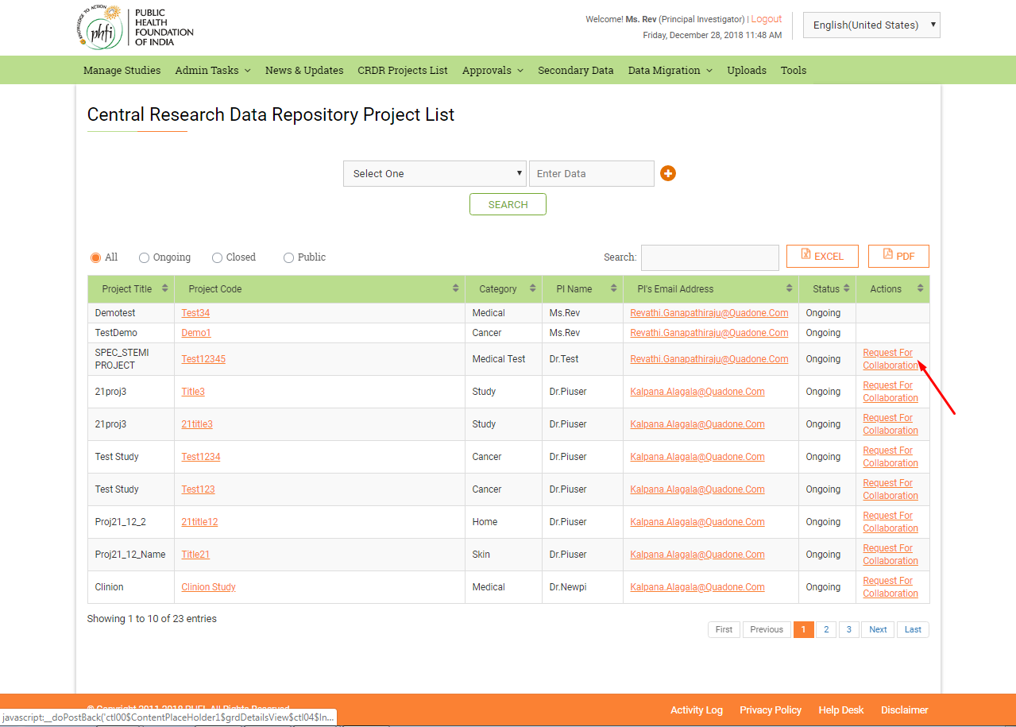

On Clicking “Request for Collaboration” a pop up will appear on screen. User needs to click on “Click here to download” to download the request for collaboration document. PI (Requester PI) needs to fill the document and upload it at “Upload file” section and submit the request.

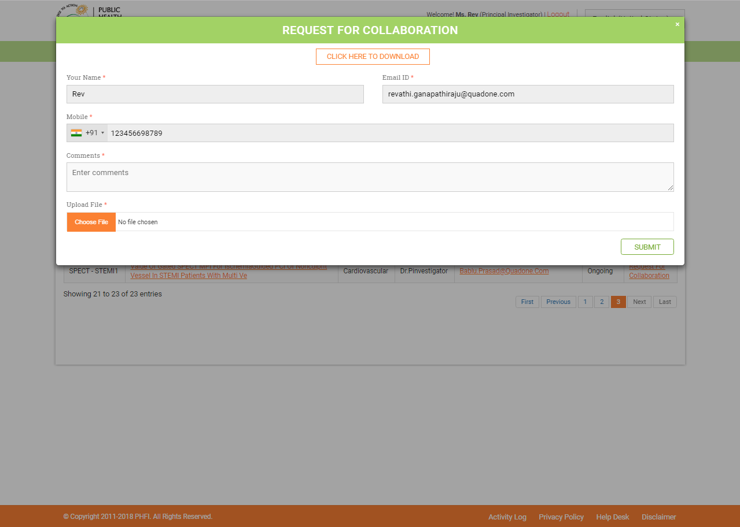

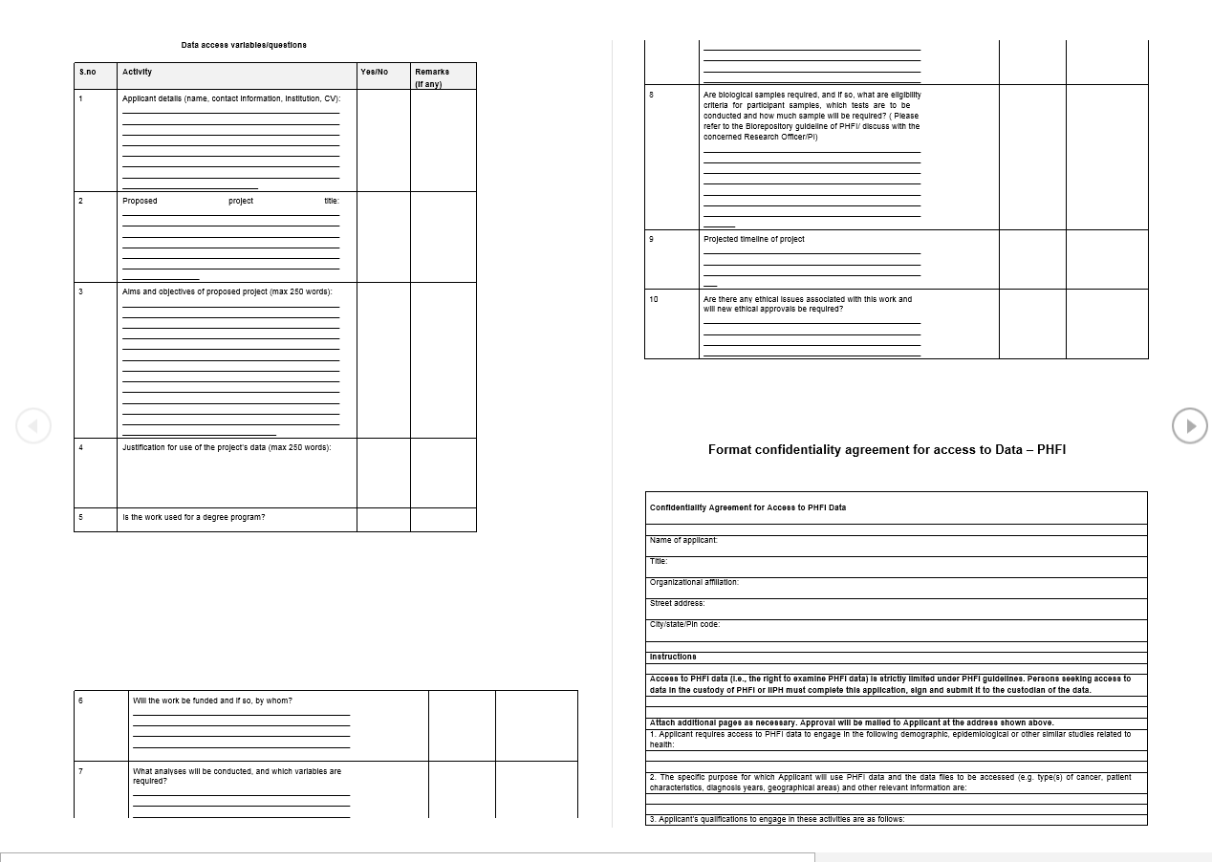

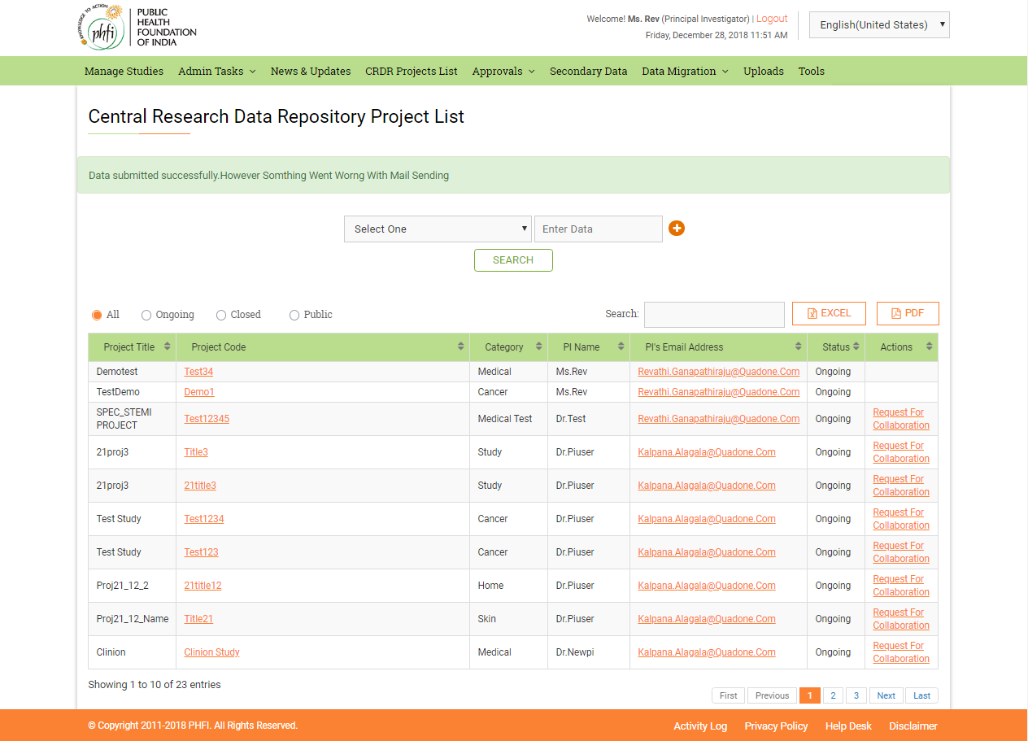

Once the request has been submitted, Study owner (study PI) will receive an email notification with the attached document.

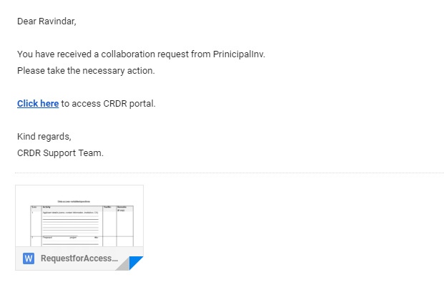

## How to Accept a Collaboration Request

1. Login using the Study owner PI username and password.
2. On logging in System navigates user to Manage Studies page. Where all the studies assigned to him are listed.
3. To find the collaboration requests received from various PIs, Click on

**Approvals< Collaboration Request.**

## Collaboration Requests

On clicking open, Collaboration page user finds all the requests for collaboration from various PIs.

The request can be either accepted or declined.

On Accepting, the requester becomes the collaborator for the study. Has all the access to the study.

